Cavolo Nero, Kale & Hispi Cabbage Information Pack
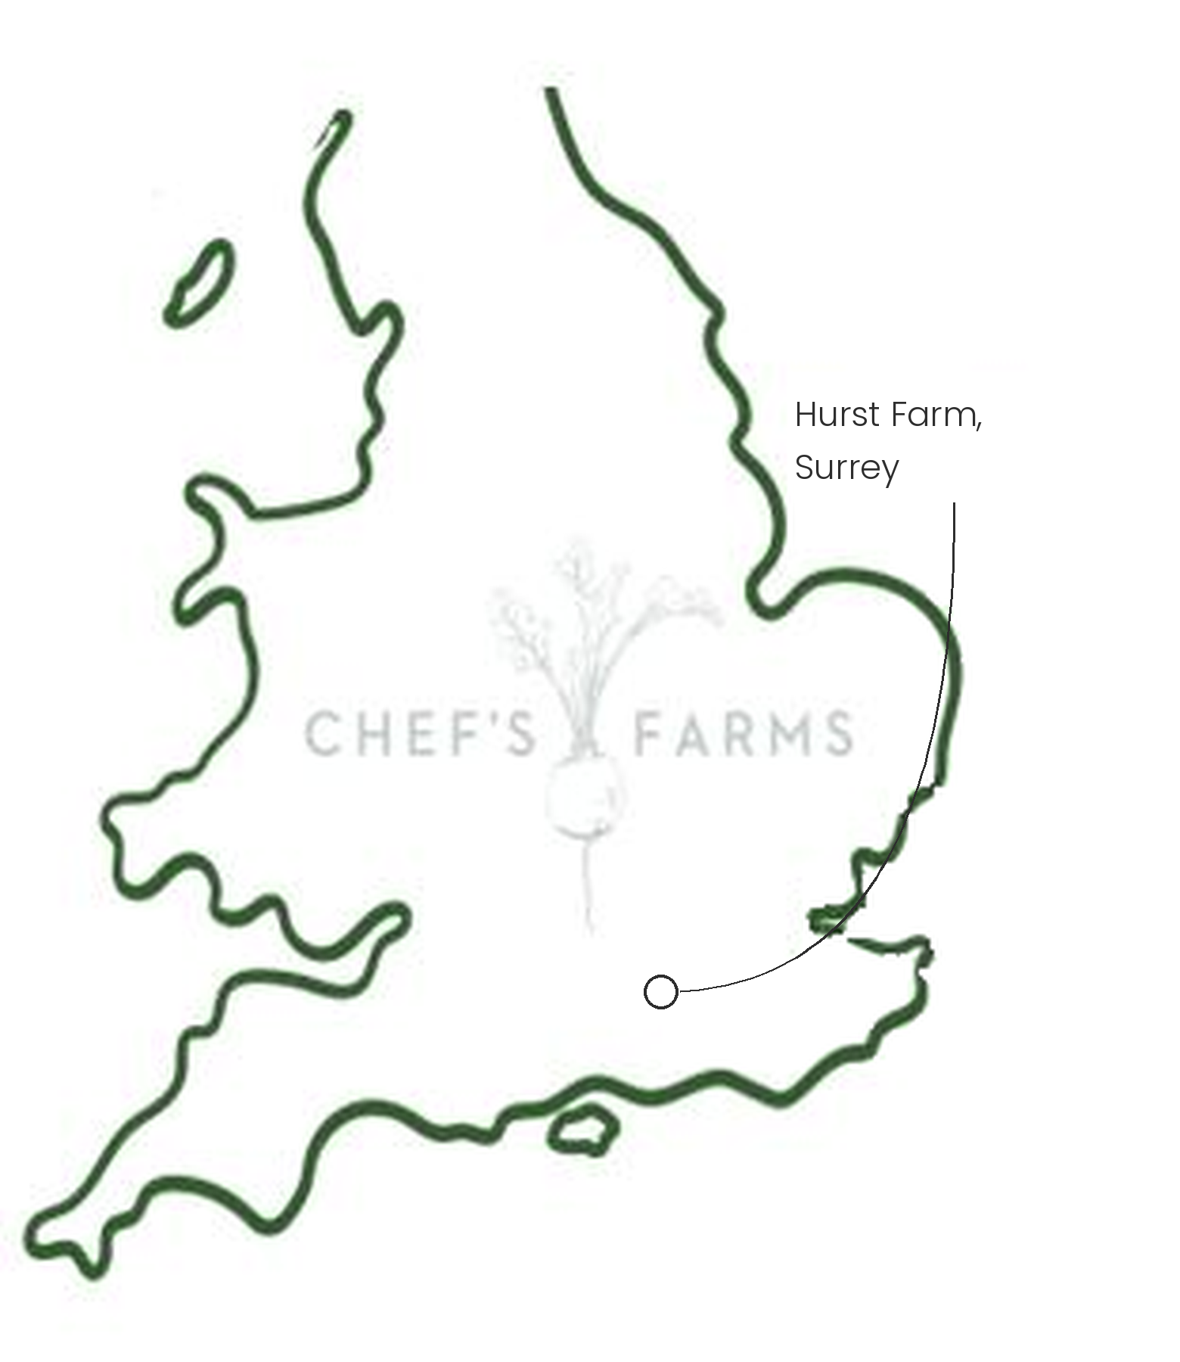
Introduction
Cavolo nero, kale and hispi look like three very different vegetables, but they are all the same species, bred over centuries for different parts of the plant. Greg grows all three side by side at Hurst Farm, giving a run of brassicas from sweet, tender hispi in summer through to frost-sweetened kale and cavolo nero in the depths of winter.
Farm Information
Hurst Farm sits in Milford, Surrey, where Greg Secrett and the team harvest all of their crops to order, hugely reducing waste and guaranteeing freshness.
Brassicas spend the summer building a big frame of leaves, capturing sunlight and storing that energy as starch. As the weather turns cold, the plant converts some of this starch into sugar, which acts as a natural antifreeze. This is why kale and cavolo nero taste sweeter after a frost. They stand in the field right through winter and are picked leaf by leaf, so each plant keeps producing for months. Hispi is quicker growing and is cut as a whole head through summer and autumn.
Brassicas share the same pests: cabbage white caterpillars, flea beetle, cabbage root fly and pigeons, along with clubroot, a soil disease that can linger for years. Growing them in the same ground year after year lets these problems build up, so Greg rotates the brassicas around the farm, giving each field a long break before they return. They are also grown in strips alongside other crops rather than one large block, breaking up the monoculture and keeping the pests 'on their toes' as it were. Protective netting keeps the butterflies and pigeons off without the need to spray, and natural composts keep the soil healthy.
We are incredibly proud to support Greg and the team.
More
Kale and cavolo nero are at their best from autumn through to early spring, while hispi runs from summer into autumn. Strip cavolo and kale leaves from the stalk before blanching or sautéing, or roast them until crisp. Hispi is excellent halved and charred hard on the grill.
Nutritionally, all three are a good source of vitamins C and K, folate and fibre, and kale and cavolo nero are also rich in beta-carotene (vitamin A).
Media
See shared album

